Comparison:

Frame Size | Hit Rate | Miss Rate
3 | 2 | 8
4 | 2 | 8
5 | 4 | 6
6 | 4 | 6

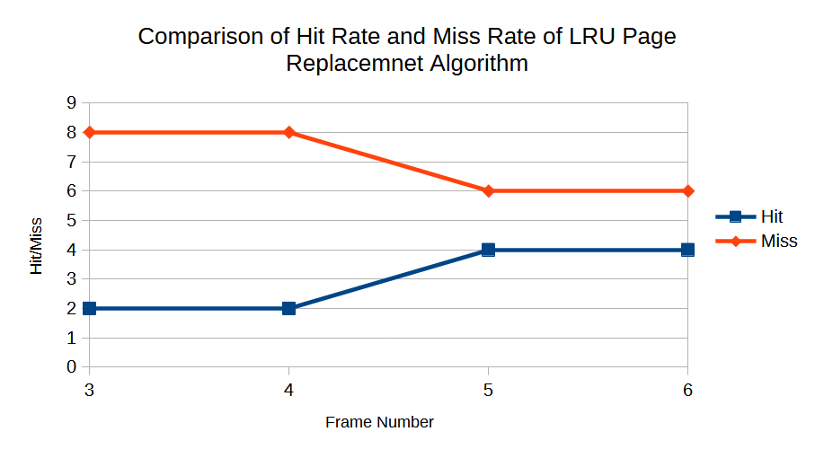
Graph:

